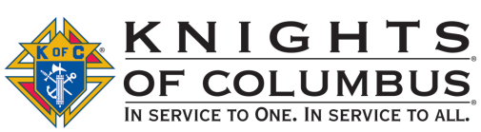
Knights of Columbus
7th Annual
Charity Golf Tournament

Beneficiary: Misericordia Nursing & Rehabilitation Center
998 S. Russell St York, Pennsylvania 17402
717-755-1964
www.mn-rc.org
Misericordia Mission: To serve our residents with a heart of mercy by providing kind, patient and compassionate care that meets individual needs and preferences.

Council #6353
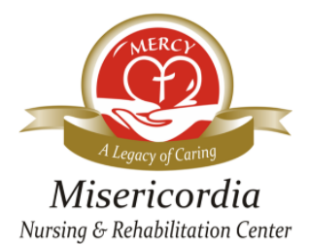

Friday, June 9, 2023 Rain or Shine 10:30-12:00pm: Registration
Heritage Hills Golf Resort 11:00-12:15pm: Driving Range and Lunch
2700 Mt Rose Ave - York PA 17402 12:30: Shotgun Start
4 Person Scramble Format Dinner and Prizes immediately following play
Price: $95/person; includes 18 holes, cart, lunch, dinner, beverages
SIGN UP EARLY TO ASSURE A SPOT! Sponsorships Available

===============================================================================================================
Mail this form with check(s) made payable to “Knights of Columbus #6353.” Mail to:
Knights of Columbus - Attn: Golf Tournament
2935 Kingston Rd - York, Pennsylvania 17402

INDIVIDUAL REGISTRATION
Name __________________________________________ Staying for dinner Y__ N__
Address _______________________________________________
Phone Number (__________) ____________-_________________
Email _________________________________________________

GROUP REGISTRATION
Team Captain ____________________________________ Staying for dinner Y__ N__
Address _______________________________________________
Phone number (__________) ____________-_________________
Email__________________________________________________

Player 2 Name ____________________________________ Staying for dinner Y__ N__
Player 3 Name ____________________________________ Staying for dinner Y__ N__
Player 4 Name ____________________________________ Staying for dinner Y__ N__

SPONSORSHIP – For more info call (717) 683-2465
___Tee/Green $300 See next page for all sponsorship level details
___Silver $500
___Gold $750
___Diamond $1200
Presenting Bellomo & Associates, LLC. $3500
Sponsor Name _________________________________________
Company ______________________________________
Address _______________________________________
Phone Number _______________________Email _______________________________

For additional tournament information or sponsorship opportunities, please email: KAWRUNNER77@YAHOO.COM or call 1-(717) 683-2465.

Knights of Columbus
7th Annual Charity Golf Tournament

SPONSORSHIP OPPORTUNITIES | Presenting  $3,500 | Diamond  $1,200 | Gold  $750 | Silver  $500 | Tee/Green  $300
Registration, green fees, golfcart, lunch & dinner | 4 golfers | 4 golfers | 2 golfers | 1 golfer
Exclusive sponsor with recognition on event Cart Cards | Logo
Exclusive sponsor with recognition on venue banner | Logo
Opportunity to place information into the gift bags | X | X
Acknowledgement during dinner program | X | X | X | X | X
Recognition on registration form | X | X | X | X | X
Recognition on a tee sign placed on a teebox | Logo | Logo | Logo | Name | Name
Acknowledgement on Misericordia website | Logo | Logo | Name | Name | Name
Recognition on Welcome Banner at registration | Logo | Name | Name | Name | Name
Recognition on golf outing Cart Cards | Logo | Name | Name | Name | Name

2023 Current List of Sponsors

PRESENTING SPONSOR
Bellomo & Associates, LLC.

DIAMOND SPONSORS

GOLD SPONSORS
The Lancaster Group, LLC.

SILVER SPONSORS

TEE/GREEN SPONSORS
Vital Healthcare Solutions
Visiting Angels
Senior Commons at Powder Mill

LUNCH SPONSOR
Jersey Mike’s Subs

BEVERAGE SPONSOR

