COUNCIL 6353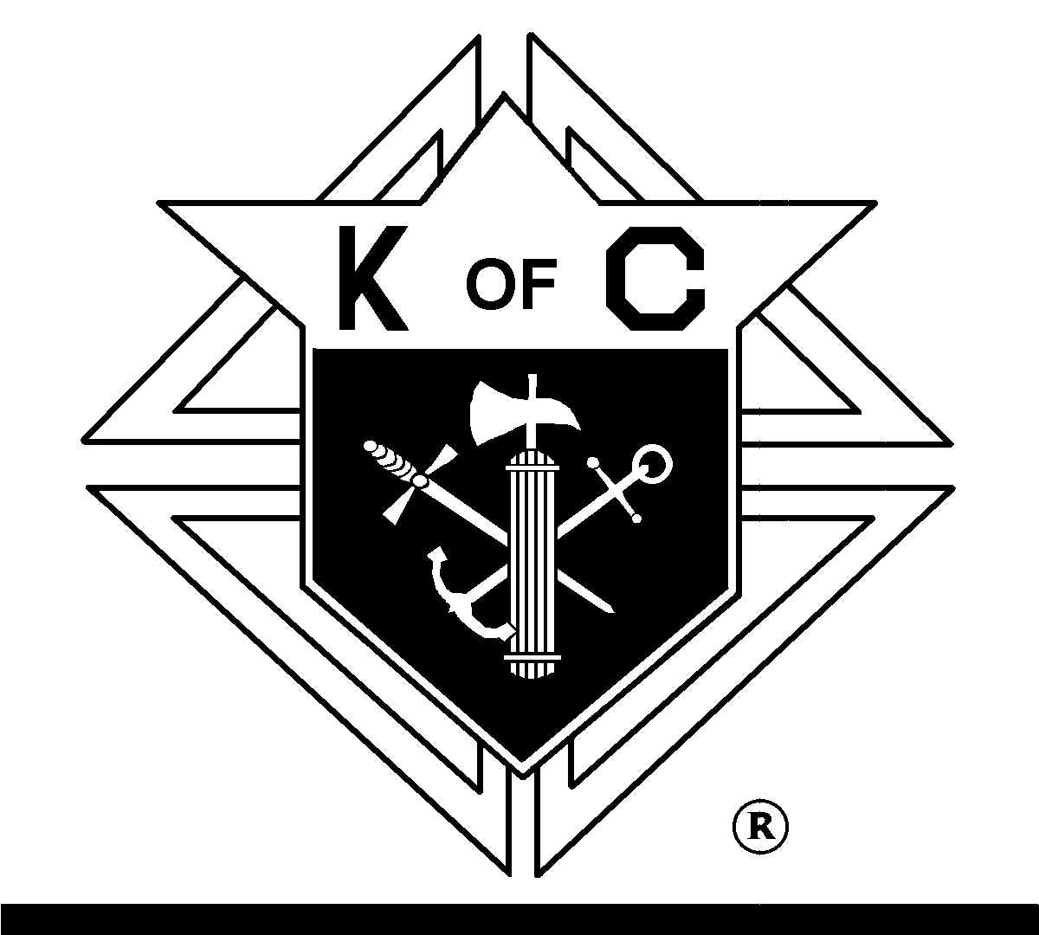
BEST WISHES FOR A VERY SUCCESSFUL
125TH PENNSYLVANIA
KNIGHTS OF COLUMBUS
STATE CONVENTION

Kelly Brown Kirk Wright
GRAND KNIGHT FINANCIAL SECRETARY
Jonathan Gnau
IMMEDIATE PAST GRAND KNIGHT
6353 ROLLS!

SERVING ST. JOSEPH EAST YORK PARISH, ST. JOSEPH AND YORK CATHOLIC SCHOOLS AND OUR COMMUNITY FOR 51 YEARS!

