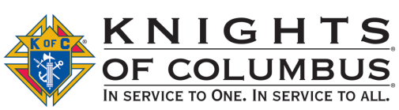
Knights of Columbus
7th Annual
Charity Golf Tournament

Beneficiary: Misericordia Nursing & Rehabilitation Center
998 S. Russell St York, Pennsylvania 17402
717-755-1964
www.mn-rc.org
Misericordia Mission: To serve our residents with a heart of mercy by providing kind, patient and compassionate care that meets individual needs and preferences.

Council #6353
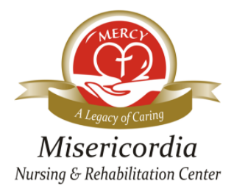

Friday, June 9, 2023 Rain or Shine 10:30-12:00pm: Registration
Heritage Hills Golf Resort 11:00-12:15pm: Driving Range and Lunch
2700 Mt Rose Ave - York PA 17402 12:30: Shotgun Start
4 Person Scramble Format Dinner and Prizes immediately following play
Price: $95/person; includes 18 holes, cart, lunch, dinner, beverages
SIGN UP EARLY TO ASSURE A SPOT! Sponsorships Available

===============================================================================================================
Mail this form with check(s) made payable to “Knights of Columbus #6353.” Mail to:
Knights of Columbus - Attn: Golf Tournament
2935 Kingston Rd - York, Pennsylvania 17402

INDIVIDUAL REGISTRATION
Name __________________________________________ Staying for dinner Y__ N__
Address _______________________________________________
Phone Number (__________) ____________-_________________
Email _________________________________________________

GROUP REGISTRATION
Team Captain ____________________________________ Staying for dinner Y__ N__
Address _______________________________________________
Phone number (__________) ____________-_________________
Email__________________________________________________

Player 2 Name ____________________________________ Staying for dinner Y__ N__
Player 3 Name ____________________________________ Staying for dinner Y__ N__
Player 4 Name ____________________________________ Staying for dinner Y__ N__

SPONSORSHIP – For more info call (717) 487-0234
___Tee/Green $300 See next page for all sponsorship level details
___Silver $500
___Gold $750
___Diamond $1200
Presenting Bellomo & Associates, LLC. $3500
Sponsor Name _________________________________________
Company ______________________________________
Address _______________________________________
Phone Number _______________________Email _______________________________

For additional tournament information or sponsorship opportunities, please email
jkgman@yahoo.com or call (717) 487-0234.

Knights of Columbus
7th Annual Charity Golf Tournament

SPONSORSHIP OPPORTUNITIES | Presenting  $3,500-Only  1-Sponsor | Diamond  $1,200  Unlimited | Gold  $750  Unlimited | Silver  $500  Unlimited | Tee/Green  $300  Unlimited
Registration, green fees, golfcart, lunch & dinner | 4 golfers | 4 golfers | 2 golfers | 1 golfer
Exclusive sponsor with recognition on event Cart Cards | Logo
Exclusive sponsor with recognition on venue banner | Logo
Opportunity to place information into the gift bags | X | X
Acknowledgement during dinner program | X | X | X | X | X
Recognition on registration form | X | X | X | X | X
Recognition on a tee sign placed on a teebox | Logo | Logo | Logo | Name | Name
Acknowledgement on Misericordia website | Logo | Logo | Name | Name | Name
Recognition on Welcome Banner at registration | Logo | Name | Name | Name | Name
Recognition on golf outing Cart Cards | Logo | Name | Name | Name | Name

2023 Current List of Sponsors

PRESENTING SPONSOR
Bellomo & Associates, LLC
DIAMOND SPONSORS
Country Meadows Retirement Communities
RT1 Services
Providence Place Senior Living
HILTZ Propane Systems, Inc.
GOLD SPONSORS
The Lancaster Group, LLC
Grane Hospice Care
ResCare, Inc.
RLPS Architects
St. Rose of Lima Columbiettes Auxiliary #10870
Swag Sponsors
Gunn-Mowery, LLC-Swag-Ball Repair Tool/Tees
Hanger Clinic-Swag-Golf Towels
SILVER SPONSORS
BrightStar Care
TEE/GREEN SPONSORS
Vital Healthcare Solutions, LLC
Visiting Angels
Senior Commons at Powder Mill
RKL LLP
Smith Wealth Advisory Group of Janney Montgomery Scott
Wagman Construction
York Catholic Middle & High School
Minnich’s Pharmacy
The Groundsmaster
Griffith, Lerman, Lutz & Scheib
Inch & Company Real Estate-Agent Jennifer Kibler
Memorial White Rose Hospice
LUNCH SPONSOR
Jersey Mike’s Subs
BEVERAGE SPONSOR

