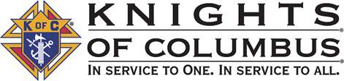

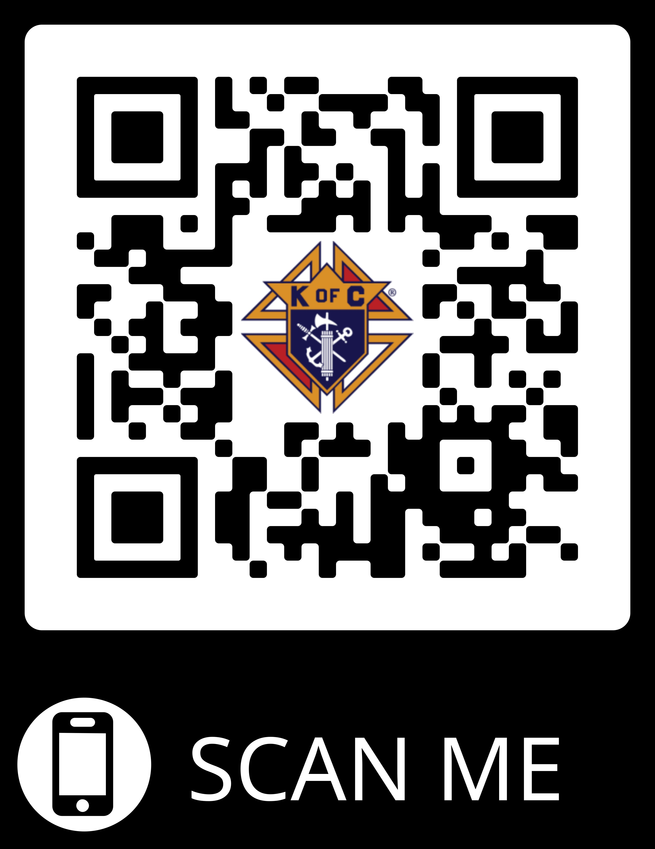
Join the Knights of Columbus for free!
kofc.org
Enter Agent Code:
ADEAKINJON
Promo Code:
BLESSEDMCGIVNEY
Enter Council # 6353
Any questions, call or text Kelly Brown at:
1-717-668-0509
Vivat Jesus!

