2024 Swag Sponsorships
As a complement to our full tournament sponsorship, we are excited to offer “swag” sponsorships for the 8th Annual Knights of Columbus Charity Golf Tournament Benefiting Misericordia Nursing & Rehabilitation Center. Some great opportunities to help a great cause and leave your name out there for even greater reach!

Golf Ball Sponsor. The centerpiece of every golf tournament is the golf ball. One carrying your logo will be a big hit! Be a special part of every stroke and associated with great memories that last a lifetime.
Premium Golf Ball Sponsorship $2000 includes a sleeve of 3 Callaway Supersoft Golf balls for up to 144 golfers.
Mid-Range Golf Ball Sponsorship $1500 includes a sleeve of 3 mid-range Callaway golf balls for up to 144 golfers.
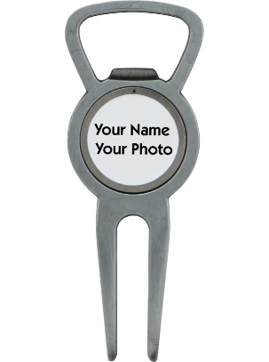
Divot Tool Sponsor $1500. Golfers are having a good day when they use this tool on the green. Be a part of some happy moments with this very useful swag item and they will celebrate you by cracking open a few! Includes divot tool with a built-in bottle opener and ball removable ball marker with your full-color logo on it for up to 144 golfers.
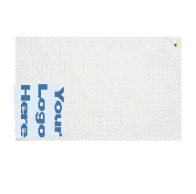
Golf Towel Sponsor $1200. Imagine your name hanging on golf bags across York County all year long. Useful and practical, some stay in use for years! Includes Microfiber Golf Towels - Colors: Athletic Gold, Black, Burgundy, Dark Green, Navy Blue, Orange, Purple, Red, Royal Blue. Decoration Information: Screen printed or Heat Transfer. 9" H x 12" W; imprint area. 15" x 15" w/ grommet with full color logo for up to 144 golfers.

Ball Marker and Tees Sponsor $1000. Talk about having your name everywhere! Get 11x the mileage with this unique swag item that golfers love! Includes bags of 10 custom 2 ¾ inch wood tees and a full color logo poker chip ball marker for up to 144 golfers.

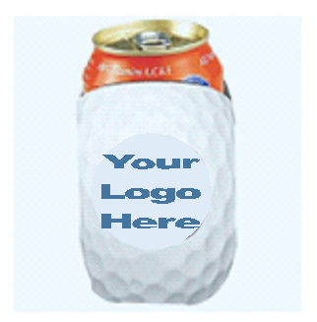
Can Cooler Sponsor $700. Be the coolest sponsor of the tournament by providing up to 144 golfers with these golf ball themed can coolers emblazed with your full color logo!

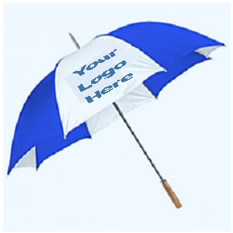
Umbrella Sponsor $2500. Made with eco-friendly rPET polyester. Auto open folding umbrella. Rubberized sure grip handle, a 44" arc, and is built with 3 section steel and fiberglass windproof construction! Powered by RainAlertz app, telling you when it's going to rain. Colors: Navy Blue, Burgundy Red, Hunter Green, Orange/White, Purple, Red/White, Royal Blue, Black, Red Decoration Information: Screen printed. 8" W x 5" H. For up to 144 golfers.

To add your Swag Sponsorship to your primary sponsorship or for more information on purchasing a Swag Sponsorship only, contact Sean Brennan at: sfbrennan@comcast.net or call 717-309-5044. Logo orders will need to be received by May 14th to insure time for processing.

Items will be purchased upon the granting of the sponsorship. Item colors will be chosen to best complement the company logo. Items may differ from the ones pictured, but they will be similar in quality and functionality. Any left-over swag will be given as prizes or to non-playing guests.

Add-on Swag Sponsorship Sign-up Form

Please fill in your information below to sign up for a Swag Sponsorship for the 8th Annual Knights of Columbus Charity Golf Tournament Benefitting Misericordia Nursing and Rehabilitation Center:

Company Name: ___________________________
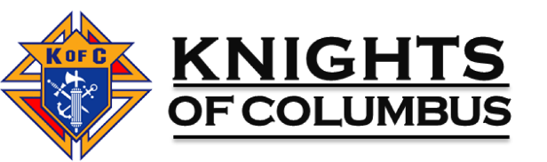
Contact Person: ___________________________

Phone Number: ___________________________

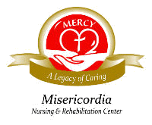
Email Address: ___________________________

Swag Sponsorship Selected:

[ ] Golf Ball Sponsor (Premium) - $2000

[ ] Golf Ball Sponsor (Mid-Range) - $1500

[ ] Divot Tool Sponsor - $1500

[ ] Golf Towel Sponsor - $1200

[ ] Ball Marker and Tees Sponsor - $1000

[ ] Can Cooler Sponsor - $700

[ ] Umbrella Sponsor - $2500

Total Amount: $_______________________

Payment: Check made payable to Knights of Columbus #6353.

Mail to:
Knights of Columbus
Attn: Golf Tournament
2935 Kingston Rd
York, Pennsylvania 17402

Please email this completed form to Sean Brennan at: sfbrennan@comcast.net by May 14th to ensure time for processing. Thank you for supporting our charity golf tournament!

